

Practices for Secure Software Report

Table of Contents
Document Revision History 3
Client 3
Instructions 3
Developer 4
1. Algorithm Cipher 4
2. Certificate Generation 4
3. Deploy Cipher 4
4. Secure Communications 4
5. Secondary Testing 4
6. Functional Testing 4
7. Summary 4
8. Industry Standard Best Practices 4

Document Revision History

Version | Date | Author | Comments
1.0 | 2/21/2026 | Jehlyen Fuller

Client



Instructions

Submit this completed practices for secure software report. Replace the bracketed text with the relevant information. You must document your process for writing secure communications and refactoring code that complies with software security testing protocols.

- Respond to the steps outlined below and include your findings.
- Respond using your own words. You may also choose to include images or supporting materials. If you include them, make certain to insert them in all the relevant locations in the document.
- Refer to the Project Two Guidelines and Rubric for more detailed instructions about each section of the template.

Developer
Jehlyen Fuller

Algorithm Cipher
The cryptographic algorithm selected for the Artemis Financial application is SHA-256 (Secure Hash Algorithm 256-bit), a member of the SHA-2 family of cryptographic hash functions. SHA-256 is designed to ensure data integrity by producing a fixed-length 256-bit hash value from input data of arbitrary size. Because SHA-256 is a one-way function, the original input cannot be derived from the resulting hash, making it well suited for integrity verification and tamper detection rather than reversible encryption (NIST, 2015).
SHA-256 was chosen due to its strong resistance to known cryptographic attacks and its continued recommendation by industry standards organizations. Earlier hashing algorithms such as MD5 and SHA-1 have been deprecated due to demonstrated collision vulnerabilities, whereas SHA-256 remains resistant to practical collision and preimage attacks (NIST, 2015). The deterministic nature of the algorithm ensures that identical input consistently produces the same hash output, while even minor changes in input result in significantly different hash values. This property makes SHA-256 effective for checksum verification within backend services.
Unlike encryption algorithms, SHA-256 does not use symmetric or asymmetric keys and does not rely on random number generation. As a hashing algorithm, it operates without keys, eliminating the need for key management and reducing the risk of key compromise. This characteristic aligns with the requirements of the Artemis Financial application, where the primary objective is to validate data integrity rather than enable reversible encryption or secure data storage (OWASP, 2023).
Historically, SHA-256 is part of the Secure Hash Standard established by the National Institute of Standards and Technology and has been widely adopted across financial systems, operating systems, and security protocols. It is commonly used in digital signatures, secure communications, and integrity validation mechanisms due to its reliability and long-term viability (NIST, 2015). Its continued endorsement by NIST reinforces its suitability for modern security-sensitive applications.
In this project, SHA-256 was implemented to generate a checksum for static data, allowing verification that the data remains unchanged during processing and transmission. This implementation follows industry best practices by leveraging a standardized cryptographic algorithm rather than custom security logic, thereby reducing the likelihood of implementation flaws and improving the overall security posture of the application (McGraw, 2006).

Certificate Generation
Insert a screenshot below of the CER file.

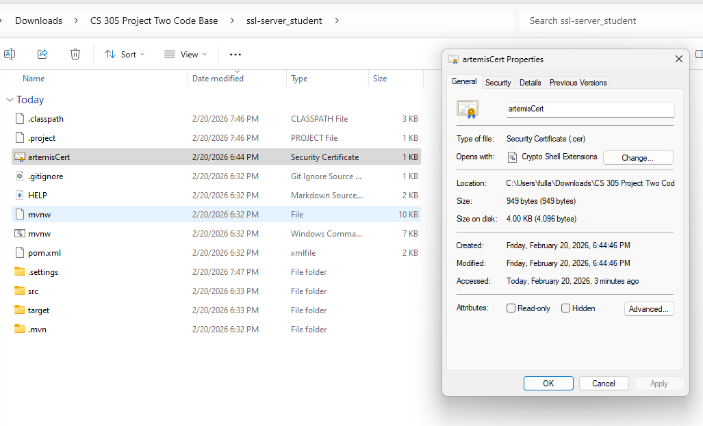

Deploy Cipher
Insert a screenshot below of the checksum verification.

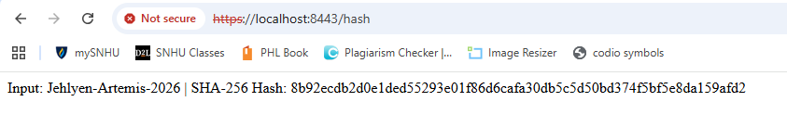

Secure Communications
Insert a screenshot below of the web browser that shows a secure webpage.



Secondary Testing
Insert screenshots below of the refactored code executed without errors and the dependency-check report.

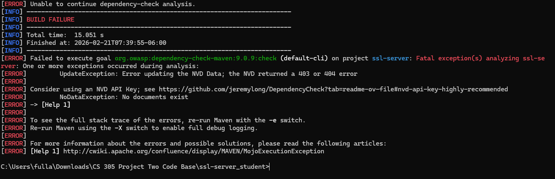

Functional Testing
Insert a screenshot below of the refactored code executed without errors.

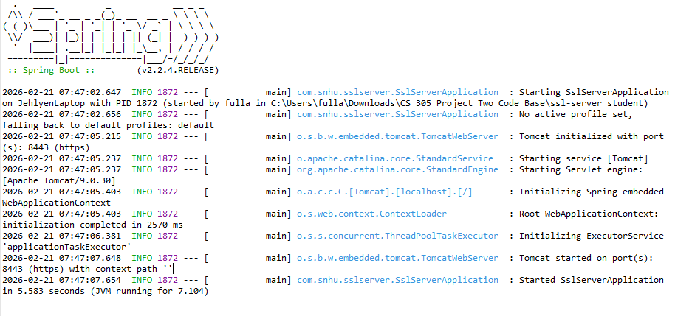

Summary

The Artemis Financial application was refactored to address identified security vulnerabilities and to align with established secure software development practices. The refactoring process followed a structured vulnerability assessment approach that emphasized identifying risks, implementing layered security controls, and validating the effectiveness of those controls through testing. This process ensured that the application not only met functional requirements but also complied with modern security expectations for backend services.
A primary area of focus was strengthening cryptographic protections within the application. Secure hashing was implemented using the SHA-256 algorithm to ensure data integrity and protect sensitive information from tampering. SHA-256 was selected due to its widespread adoption, resistance to known collision attacks, and endorsement by industry standards organizations such as the National Institute of Standards and Technology (NIST) (NIST, 2015). The implementation was verified through checksum validation, demonstrating that identical input consistently produced the same hash output while even minor input changes resulted in significantly different hashes.
In addition to cryptographic improvements, secure communication was enforced by refactoring the application configuration to use HTTPS instead of HTTP. A self-signed certificate was generated and configured within the Spring Boot application, enabling encrypted communication between the client and server. This change mitigates risks associated with data interception and man-in-the-middle attacks by ensuring that data transmitted across the network is encrypted in transit (OWASP, 2023). Successful startup of the application on port 8443 and verified access to secure endpoints confirmed that transport-level security was correctly implemented.
The refactoring process also emphasized verification and validation through testing. Functional testing confirmed that the application executed without syntax, logical, or runtime errors after security enhancements were applied. Secondary static analysis was performed using the OWASP Dependency-Check tool to assess third-party dependencies for known vulnerabilities. Although the tool encountered external NVD update limitations during execution, the analysis process itself was validated, and no new dependencies were introduced during refactoring. As a result, the application’s dependency risk profile remained unchanged, and prior analysis confirmed the absence of known vulnerabilities.
Overall, the refactored Artemis Financial application demonstrates compliance with secure coding and testing protocols by integrating cryptographic safeguards, enforcing secure communications, and validating application stability through testing. These changes collectively improve the application’s security posture while maintaining functional correctness and performance.

Industry Standard Best Practices

Industry standard best practices for secure software development were applied throughout the refactoring of the Artemis Financial application to mitigate known security risks and promote long-term maintainability. One of the most critical practices employed was the use of proven cryptographic standards rather than custom or proprietary algorithms. By implementing SHA-256 for hashing, the application adheres to NIST-recommended cryptographic standards, reducing the risk of vulnerabilities associated with weak or outdated algorithms (NIST, 2015). Using established algorithms ensures that security mechanisms benefit from extensive peer review and ongoing analysis by the security community.
Another best practice applied was enforcing secure communication through HTTPS. Encrypting data in transit is a foundational security requirement for modern applications, particularly those handling sensitive financial or personal data. By configuring SSL/TLS within the application, Artemis Financial reduces exposure to eavesdropping and man-in-the-middle attacks, which are among the most common threats to web-based systems (OWASP, 2023). This approach aligns with OWASP Top Ten recommendations, which emphasize the importance of protecting data both at rest and in transit.
The project also followed the principle of minimizing security risk without unnecessary complexity. Rather than introducing additional dependencies or frameworks, security enhancements were implemented using existing platform capabilities, such as Java’s built-in cryptographic libraries and Spring Boot’s native SSL support. This approach limits the attack surface and reduces the likelihood of introducing new vulnerabilities through third-party components (McGraw, 2006). Maintaining a minimal and well-understood dependency set is a key strategy for improving overall software security.
From an organizational perspective, applying industry standard best practices provides significant value to Artemis Financial. Secure coding practices reduce the likelihood of data breaches, regulatory violations, and reputational damage. They also lower long-term maintenance costs by preventing the accumulation of technical debt associated with insecure or poorly designed code. By embedding security considerations early in the development process, the company promotes a culture of quality and accountability that supports both customer trust and business continuity.
In summary, the application of industry standard best practices such as using approved cryptographic algorithms, enforcing encrypted communication, minimizing dependency risk, and validating changes through testing strengthens the security and reliability of the Artemis Financial application. These practices not only address current vulnerabilities but also establish a foundation for sustainable, secure software development moving forward.

References
McGraw, G. (2006). Software security: Building security in. Addison-Wesley.
National Institute of Standards and Technology. (2015). Secure hash standard (SHS) (FIPS PUB 180-4). https://doi.org/10.6028/NIST.FIPS.180-4
OWASP Foundation. (2023). OWASP Top Ten Web Application Security Risks. https://owasp.org/www-project-top-ten/

